**1.3/1.4A – Investigating Quadratic Functions in Standard Form: *y* = *a*(*x* ± *h*)2 ± *k***

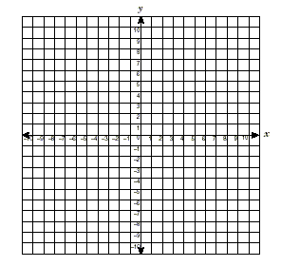 Graph using a table of values

Quick way to graph:

Use a basic count:

Start at vertex: in this case (0,0)

Over 1, back to vertex Over 2, back to vertex Over 3,

|  |  |
| --- | --- |
| *x* | *y* |
| -3  -2  -1  0  1  2  3 |  |



Graph Shape: the graph shape is called a _______________ and occurs when the equation has an ___________________.

Parabolas have a ___________________, a middle point. For, it is

Parabolas have an AXIS OF SYMMETRY, a reflection line that splits the parabola into _________ _______________________________________________. It can be shown with a dashed line.

In this example, the equation of the axis of symmetry is

Parabolas open _____________ or _______________. If they open upwards, they go up forever and ever, but only go down so far. Therefore, they have a _________________ value. In the example above, the minimum value is _________________. If they open downwards, they go down forever, but only go up so far. Therefore, they have a __________________ value.

For any graph, you can find the __________. For any graph, you can find the _________. How far left does the graph go? How far right? How far up does the graph go? How far down? In this example, In this example,

A quadratic function is a function that has a second degree polynomial (has an x2 term, but nothing higher. The graph shape that results is a PARABOLA.

Examples:

*Note: *f(x)* is the same as *y*

***k* value**

a) Graph *y* = *x2* using the basic count: Start at (0,0) and go over 1,

over 2,

over 3,

*y = x2* ± *k*

b) Graph using a table of values:

|  |  |
| --- | --- |
| *x* | *y* |
| -3  -2  -1  0  1  2  3 |  |

Notice:

Vertex:

A of S eqn:

Max/Min:

Domain:

Range:

c) Graph by count method:

*k* value is:

Vertex is:

Then do basic count:

Vertex: A of S eqn:

Max/Min: Domain:

Range:

***y = x2 ± k***

**The *k* value:**

***h* value**

a) Graph *y* = *x*2 using the count

b) Graph using a table of values

|  |  |
| --- | --- |
| *x* | *y* |
| 1  2  3  4  5  6  7 |  |

Notice:

Vertex:

A of S eqn:

Max/Min:

Domain:

Range:

*y* = (*x*±*h*)2

*h* valueMental Switch:

c) Graph using the count method:

Vertex: Domain:

A of S eqn: Range:

Max/Min:

***y* = (*x* ± *h*)2 ± *k*: Vertex Notes:**



Example - Graph $y={\left(x+2\right)}^{2}-5$ using the count method

Vertex: Domain:

A of S eqn: Range:

Max/Min:

**Practice**

**1.4B – Investigating Quadratic Functions in Standard Form: *y* = *a*(*x* ± *h*)2 ± *k***



a)Graph $y=x^{2}$ using the count.

b) Graph using a table of values

|  |  |
| --- | --- |
| *x* | *y* |
| -3  -2  -1  0  1  2  3 |  |

Notice:

***a* value**

*y* = *ax*2

c) Graph  using the count method:

**The *a* value:**



Graph using a table of values

|  |  |
| --- | --- |
| *x* | *y* |
| -3  -2  -1  0  1  2  3 |  |

Vertex: Domain:

A of S eqn: Range:

Max/Min:



**The –*a* value:**

Graph using the count method

**Standard Form: Notes:**



Graph a) 

and b)

For each, find the

* vertex
* axis of sym eqn
* max/min
* domain
* range

a)Vertex: b) Vertex:

A of S eqn: A of S eqn:

Max/Min: Max/Min:

Domain: Domain:

Range: Range:

***x*-ints** Thinking back to last chapter, what are *x*-intercepts?

How many *x*-intercepts for a quadratic function?

What are the methods we learned to identify *x*-intercepts?

Example 1 – Determine the number of x-intercepts for each quadratic function, and also determine the *y*-intercept of each.

1. $y=-2{\left(x-7\right)}^{2}-1$ b) $y=0.5x^{2}-6$ c) $y=-2{\left(x+1\right)}^{2}$

Example 2 – Write a quadratic function with a maximum of 3, axis of symmetry equation

*x= -1*, that passes through (1, 1).

**2.1 – Finding the Equation of a Parabola**

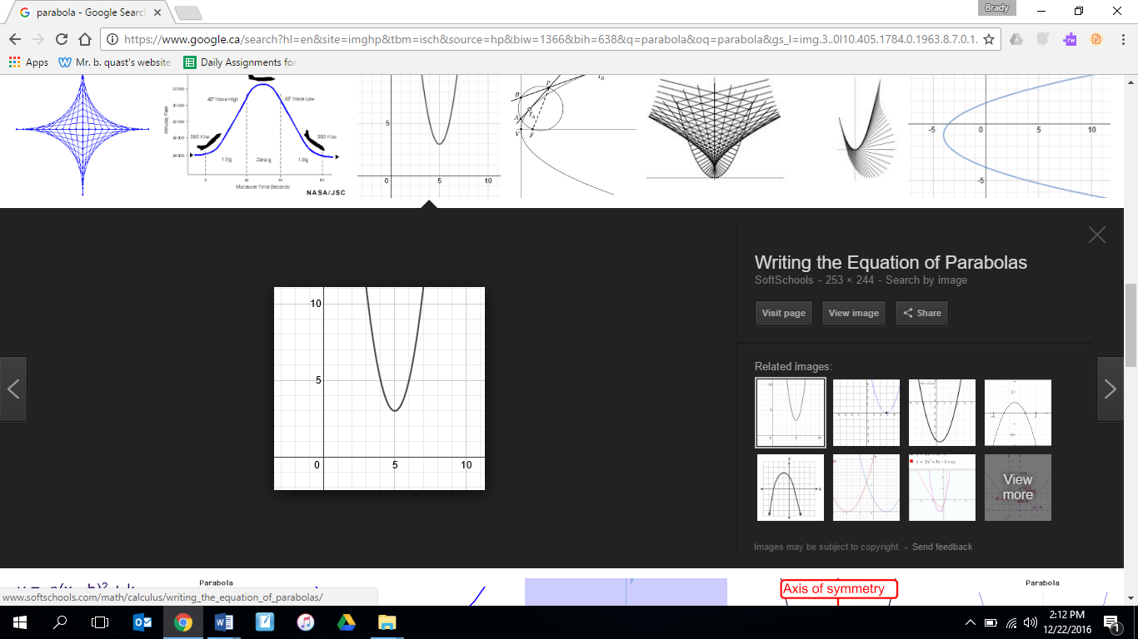Example 1 – Determine the equation of the following parabola:

Example 2 – Find the equation of a quadratic function whose graph has vertex (4, 8) and an

*x*-intercept of 6.

Example 3 – A parabola with vertex (1, -2) passes through the point (4, 1). Find the equation.

Example 4 – Find an equation of a quadratic function with points (3, -4), (-3, 2), & (1, 2).

**2.2 – Completing the Square**

When quadratic functions are in GENERAL FORM [$y=ax^{2}±bx±c]$, they can be changed into STANDARD FORM [$y={\left(x±p\right)}^{2}±q$] using a technique called

**completing the square**

_____________________________________________________________.

Example 1 - Rewrite in standard form by completing the square.

Then sketch the graph. Calculate the *x*-intercepts.

STEPS:

1. Rearrange so squared term is first and *x* term is second.
2. Find the *a, b, c* values
3. Take half the b-value (you’ll need this later), then square it.
4. Add and subtract the result to your quadratic function after the *x* term.
5. Make sure the new term you added is the third term.
6. Factor the trinomial and add the two last terms.

Shortcut for factoring the trinomial:



Example 2- Change  into standard form, then calculate the *x*-intercepts.

**When a $≠$ 1** When the *a* value is different from 1, there are a few more steps.

Example 3 - Change  into standard form and then find *x*-ints

STEPS:

1. Group the first two terms together.
2. Factor the *a* value out.
3. Find the *b* value. Take half and square it.
4. Add and subtract the result IN THE BRACKETS.
5. Get the subtracted result out of the brackets by multiplying to the coefficient in front of the brackets.
6. Factor the trinomial.

Example 4 - Change  into standard form, then calculate the *x*-ints.

Example 5 - Change  into standard form using exact values.

**2.4 – Applications of Quadratic Functions**

Example 1 - The path of a rocket fired over a lake is described by the function

$h\left(t\right)=-4.9t^{2}+49t+1.5$ where *h(t)* is the height of the rocket, in metres, and *t* is time in seconds, since the rocket was fired.

1. What is the maximum height reached by the rocket? How many seconds after it was fired did the rocket reach this height?
2. How high was the rocket above the lake when it was fired?
3. At what time does the rocket hit the ground?
4. What domain and range are appropriate in this situation?
5. How high was the rocket after 7s? Was it on its way up or down?

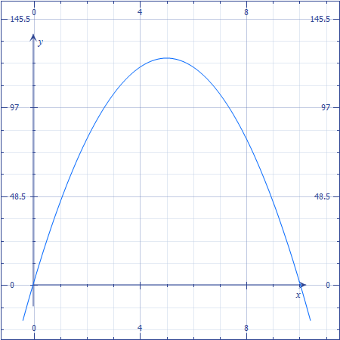

\***Keep in mind that the question presented this function in general form. Sometimes, in problems like this, the function is presented in standard form, which will make it much easier**

Example 2 – At a concert, organizers are roping off a rectangular area for sound equipment. There is 160m of fencing available to create the perimeter. What dimensions will give the maximum area, and what is the maximum area?

Steps:

1) Write an equation for perimeter, and write an equation for area for a rectangle.

2) Use the two equations to create a quadratic function in general form.

3) Complete the square to change the quadratic function into standard form.

4) Identify the maximum area, and then the dimensions for the maximum area.

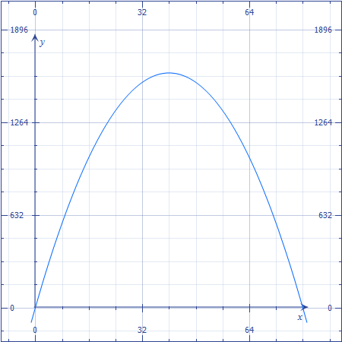

Example 3 – A rancher has 800m of fencing to enclose a rectangular cattle pen along a river bank. There is no fencing needed along the river bank. Find the dimensions that would enclose the largest area.

Example 4 – A sporting goods store sells basketball shorts for $8. At this price their weekly sales are approximately 100 items. Research says that for every $2 increase in price, the manager can expect the store to sell five fewer pairs of shorts. Determine the maximum revenue the manager can expect based on these estimates. What selling price will give that maximum revenue, and how many shorts will be sold?

