**7.0 – Trigonometry Review**

In trigonometry problems, all vertices (corners or angles) of the triangle are labeled with capital letters. The right angle is usually labeled *C*. Sides are usually labeled with lower case letters. The side opposite to *<A* will be labeled *a* and so on.

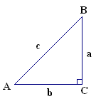

Whenever we do trigonometry problems on a right triangle, we focus on a target angle. The target angle can be any of the two angles that are **not** the right angle.

Once we have a target angle, we can name each side of the triangle. Let’s suppose *A* is the target angle. Then side *a* is called the ____________________ side because it is on the other side of the triangle. Side *c* is always called the _______________________ because it is the longest side, and side *b* is called the ______________________ side as it is beside <*A*. If the target angle does not have an angle measurement on it, we represent it with the greek letter theta, $θ$.



Suppose *B* is the target angle in the triangle on the right. Label all appropriate parts.

The three trigonometric ratios for right triangles are:

SINE COSINE TANGENT

$\sin{θ=\frac{opposite}{hypotenuse}} \cos{θ=\frac{adjacent}{hypotenuse}} \tan{θ}=\frac{opposite}{adjacent}$

S O H C A H T O A

What is the point of the trigonometric ratios?

Example 1 – Solve each to the nearest hundredth. a) $\cos{42°}$ b) $\tan{67°=\frac{x}{7}}$ c) $\sin{θ}=\frac{5}{9}$ d) $\cos{35°=\frac{8}{x}}$

In order to solve a right triangle, you must find the measurement of all three sides and all three angles.

Example 2 - Solve Δ*ABC* to the nearest tenth.



Example 3 – Sketch & solve Δ*ABC* to the nearest tenth where <*C*=90°, *c* =95cm & *b* =44cm

An angle that is drawn in **standard position** must have its vertex at the origin of the Cartesian plane, and its initial arm must coincide with the positive $x$-axis.

**angles in standard position**

To draw angles in standard position, we use an **initial arm** (always the positive *x*-axis) and a **terminal arm** (the final position after a rotation). The angle is labeled **θ** (*theta*). The **vertex** of the angle must be at the origin (0, 0) of a Cartesian plane. Positive angles are measured in a counterclockwise direction. Here is an example: 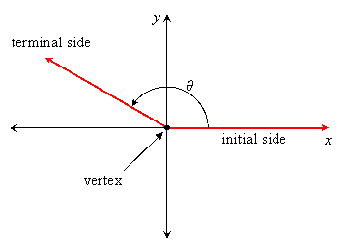

Label the four quadrants of a Cartesian plane:

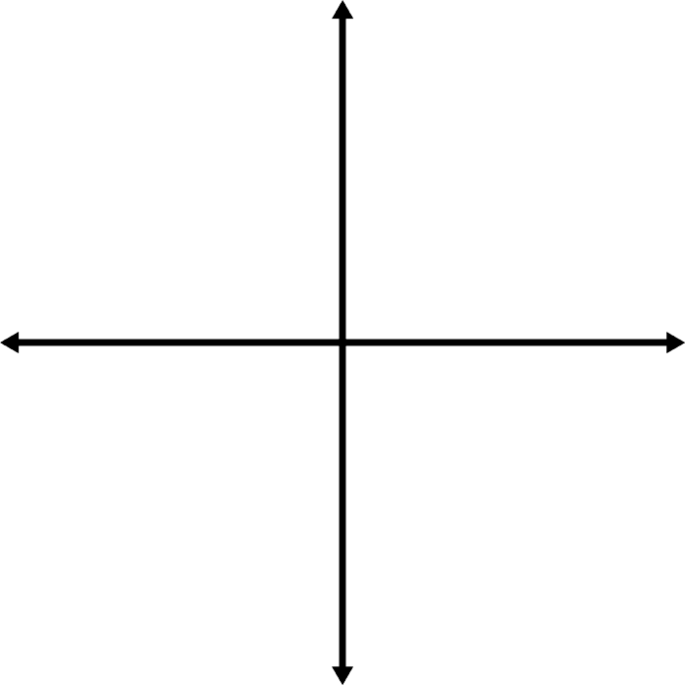

Example 4 – Draw each angle in standard position and identify the quadrant in which it lies: a) 60° b) 100° c) 300°





**7.1 – Angles and Their Measure**

An angle that is drawn in **standard position** must have its vertex at the origin of the Cartesian plane, and its initial arm must coincide with the positive $x$-axis.

Clockwise angles have a negative measure:

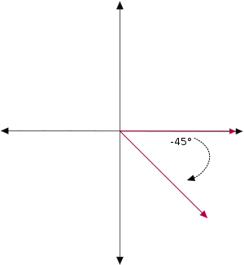

**angles in standard position**

Example 1– Draw each angle in standard position and identify the quadrant in which it lies: a) 225° b) -120° c) -290°





Angles in standard position that have the same terminal side are **coterminal**.

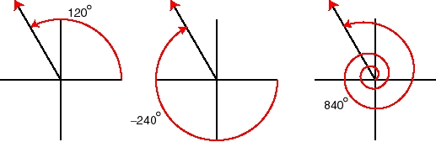

**coterminal angles**

Example 2 – Find three coterminal angles (at least one negative) for:

a) 60° b) 225°

What is a general formula to find **coterminal** angles?

For each **angle in standard position**, there is a corresponding acute angle called the **reference angle**, which is the acute angle between the terminal arm and the (nearest) *x-*axis. Thus, any reference angle is between 0° and 90°

**reference angles**

Quadrant 4



Quadrant 3



Quadrant 2



Quadrant 1



Example 3 – Draw each angle in standard position, and find the reference angle.

a) 30° b) 250° c) 325° d) 100°









Example 3 – Determine the angle in standard position when an angle of 60° is reflected

a) in the *y*-axis b) in the *x*-axis c) in the *y*-axis & then in the *x*-axis

Example 4 – Find the reference angle for:

a) 1450° b) -870°

Example 5 – Find all angles, $0°≤θ≤360°$, that have reference angles of $30°$. Do a sketch.

Find $\sin{θ}$ for each with your calculator:

Find $\cos{θ}$ for each with your calculator:

What do you notice? Why are some results positive and some negative?

As a class, let’s complete the diagram to help explain the results in Example 5:

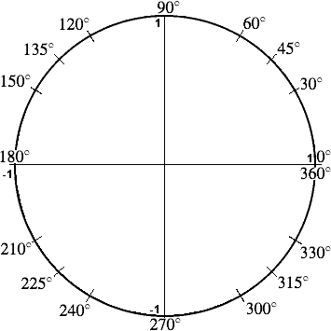

**7.2 – The Three Trigonometric Functions**

Suppose $θ$ is an angle in standard position. Suppose the point at the end of the terminal arm is labeled *P*(*x*, *y*), at a distance ***r***from the origin.

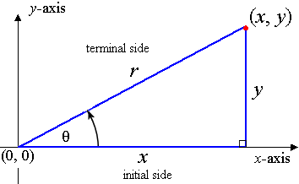

You can use a reference angle to determine the three trigonometric ratios in terms of *x*, *y*, and *r*.

$sinθ=\frac{ }{ } cosθ=\frac{ }{ } tanθ=\frac{ }{ }$

**Trigonometry ratios in the four quadrants:**

Quadrant 2 $90°<θ<180°$

Quadrant 1 $0°<θ<90°$

 

Quadrant 4 $270°<θ<360°$

Quadrant 3 $180°<θ<270°$

 

Here is a way to remember the sign of the trigonometric ratios in each quadrant:

**CAST**



Example 1 – Identify the quadrant(s) for the angles satisfying the following conditions:

a) $\sin{θ}<0, \cos{θ}>0$

b) $\tan{θ}<0, \cos{θ}<0$

Example 2 – The point *P*(-5, -12) lies on the terminal arm of an angle, $θ$, in standard position. Determine the exact trigonometric ratios for sin $θ$, cos $θ$, and tan $θ$.



Example 3 – Suppose $θ$ is an angle in standard position with terminal arm in quadrant III, and $tanθ=\frac{1}{5}$. Determine the exact values of sin $θ$ and cos $θ$.



 Example 4 – Find $\sin{α}$ if $\tan{α}=2.135$ with $α$ in Quadrant III.

Example 5 - $y=-2x, x≤0$ is the equation of the terminal side of an angle $θ$ in standard position. Sketch the smallest positive angle $θ$, and determine $\sin{θ}$, $\cos{θ}$, and $\tan{θ}$.



**7.3A – Special Angles Part 1**

Suppose $θ$ is an angle in standard position. Suppose the point at the end of the terminal arm is labeled *P*(*x*, *y*), at a distance ***r***from the origin.



You can use a reference angle to determine the three trigonometric ratios in terms of *x*, *y*, and *r*.

$sinθ=\frac{ }{ } cosθ=\frac{ }{ } tanθ=\frac{ }{ }$

A **quadrantal angle** is an angle in standard position whose terminal arm lies on one of the axes. It’s easiest to suppose the terminal arm, ***r***, has a length of 1.

Example – Find the values of sin $θ$, cos $θ$, and tan $θ$ for each quadrantal angle on the Cartesian plane.

|  |  |  |  |  |
| --- | --- | --- | --- | --- |
|  | 0° | 90° | 180° | 270° |
| sin $θ$ |  |  |  |  |
| cos $θ$ |  |  |  |  |
| tan $θ$ |  |  |  |  |



There are two right triangles in trigonometry that are especially significant because of their frequent occurrence.

A **45°-45°-90° triangle** with legs of each 1 unit has a hypotenuse of $\sqrt{2}$.

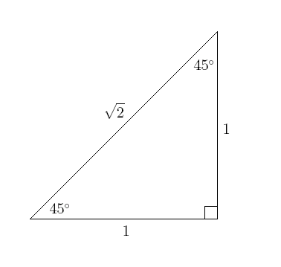 $$sinθ=\frac{opposite}{hypotenuse} cosθ=\frac{adjacent}{hypotenuse} tanθ=\frac{opposite}{adjacent}$$

$$sinθ=\frac{opposite}{hypotenuse} cosθ=\frac{adjacent}{hypotenuse} tanθ=\frac{opposite}{adjacent}$$

**S O H C A H T O A**

For the 45°-45°-90° triangle,

$$sin45°=\frac{ }{ } cos45°=\frac{ }{ } tan45°=\frac{ }{ }$$

$$sinθ=\frac{opposite}{hypotenuse} cosθ=\frac{adjacent}{hypotenuse} tanθ=\frac{opposite}{adjacent}$$

**S O H C A H T O A**

For the 45°-45°-90° triangle,

$$sin45°=\frac{ }{ } cos45°=\frac{ }{ } tan45°=\frac{ }{ }$$

**S O H C A H T O A**

$$sin45°=\frac{ }{ } cos45°=\frac{ }{ } tan45°=\frac{ }{ }$$

A **30°-60°-90° triangle** has legs of 1 unit and $\sqrt{3}$ units, with hypotenuse 2 units.

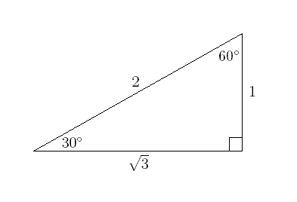

The trigonometric ratios are given as **exact values** (in fraction/radical form as opposed to an approximated decimal).

What is the CAST rule again?

Example 1 - Determine the exact values of: a) cos 135° b) sin 240° c) tan 120°



Example 2 – Evaluate $\sin{30°}$, $\sin{150°}$, $\sin{210°}$, and $\sin{330°}$.

**7.3B – Special Angles Part 2**

Warmup 2 – Quickly draw and explain the ‘CAST’ rule:

Warmup 1 – Draw the 45°-45°-90° triangle and the 30°-60°-90° triangle below:



Example 1 – Find the exact value of $\cos{240°}$



**solving for angles**

Steps for solving for angles given their sine, cosine, or tangent ratio:

1. Use the sign (+ or -) to determine the quadrant the solution is in.
2. Solve for the reference angle.
3. Draw a diagram and use the reference angle to find the angle in standard position.

Example 2 – Solve for $θ$.

c) $\sin{θ=-\frac{\sqrt{3}}{2}}, 0°≤θ≤360°$

a) $\sin{θ=-\frac{1}{\sqrt{2}}},0°≤θ<360°$ b) $\cos{θ=\frac{1}{2}, 0°≤θ<360°}$

Example 3 – Determine the measure of $θ$, to the nearest degree, given

a) $\sin{θ=-0.8090}$, where $0°≤θ<360°$ b) $\tan{θ}=-0.7565$, where $0°≤θ<360°$

**7.5 – The Sine Law**

So far, you have learned how to use trigonometry when working with right triangles. Now, you will learn how to use trigonometry for **oblique triangles** (non-right triangles).

Draw an oblique triangle *ABC* and label the sides *a*, *b*, & *c* (opposite the respective corresponding angles). Then, draw a line (call it *h*) from *B* to *b*, so that it is perpendicular to line *b*.

**developing the sine law**

Write a ratio for sin*A*, and then for sin*C*. Then, solve each for *h*.

Since each ratio is equal to *h*, they must also equal one another.

By using similar steps, you can also show the same for *b* and sin*B*.

**sine law**

For any triangle, the sine law states that the sides of a triangle are proportional to the sines of the opposite angles:

$$\frac{a}{\sin{A}}=\frac{b}{\sin{B}}=\frac{c}{\sin{C}} OR \frac{\sin{A}}{a}=\frac{\sin{B}}{b}=\frac{\sin{C}}{c}$$

Example 1 – Solve for side AB and side BC to the nearest tenth.

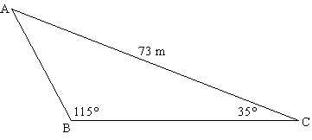

Example 2 – Solve for angle B to the nearest degree. Then find angle C to the nearest degree and side AB to the nearest tenth.

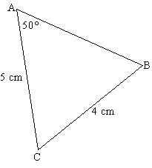

**information necessary to use the sine law**

For oblique triangles, what is the minimum information needed in order to use the sine law to find new information?

When **solving a triangle**, you must find all of the unknown angles and sides.

**solving a triangle**

Example 3 – Sketch and solve the triangle (each answer to the nearest tenth).

$<A=140°, <C=25°, a=20$

Example 4 – Solve the triangle (round to the nearest whole number).

$<B=38°, b=8, a=6$

**7.6 – The Cosine Law**

For right triangles, the trigonometric ratios sine, cosine, and tangent can be used to find unknown sides and angles. For oblique triangles, **sine law** and **cosine law** must be used.

An effective way to work with oblique triangles is to imagine the angle and its opposite side as ‘partners’. Thus, angle *A* and side *a* are partners, <*B* and *b* are partners, and <*C* and *c* are partners.

In order to use the sine law, you must know one full set of partners and half of another set. If you know only half of each set of the three partners, at least two of which are sides, you must use **cosine law**.

Example – For each oblique triangle, state which law you would use.

a) *x* =30cm, *y* =28cm, *z* =32cm (b) <*C* =27°, *a* =17m, *c* =13m (c) <*J* =41°, *k* =16cm, *p* =14cm

**deriving cosine law**

3. Next, for Δ*ABD*, write a Pythagorean equation. Then FOIL ${\left(b-x\right)}^{2}$. Can you see where $a^{2}$ can now replace a part of the equation? What can you replace for ?

1. The **cosine law** can be developed by starting with oblique Δ*ABC* and drawing vertical line *h* from <*B* to side *b*. Where *h* meets side *b*, call that vertex *D*. Side *CD* can then be labeled $x$, and side *DA* can be labeled .

2. For Δ*BCD*, find cos*C* and rearrange the equation to isolate $x$. Then write a Pythagorean equation for Δ*BCD*.

**cosine law**

The **cosine law** describes the relationship between the cosine of an angle and the lengths of the three sides of any triangle.

$$c^{2}=a^{2}+b^{2}-2ab\cos{C}$$

Cosine law can also be written as $a^{2}=b^{2}+c^{2}-2bc\cos{A}$**OR**

$b^{2}=a^{2}+c^{2}-2ac\cos{B}$

Example 1 – Kohl wants to find the distance between two points, *A* and *B*, on opposite sides of a pond. She locates a point *C* that is 35.5m from *A* and 48.8m from *B*. If the angle at *C* is 54°, determine the distance *AB*, to the nearest tenth of a metre.

Example 2 – A triangular brace has side lengths 14m, 18m, and 22m. Determine the measure of the angle opposite the 18m side, to the nearest degree.

Example 3 – In Δ*ABC*, *a* = 29cm, *b* = 28cm, and <*C* = 52°. Sketch a diagram and determine the length of the unknown side and the measures of the unknown angles, to the nearest tenth.

**using cosine law & sine law**