More Trigonometry Part 1 Review
True or False:
1. The period of $y=cos2πx$ is $π$.
2. The range of $y=4\sin{x+3}$ is $-4≤y≤4.$
3. The graph of $y=\sin{(2x+\frac{π}{6})}$has a period of $π$ and a phase shift of $\frac{π}{6}$ .
4. The points $(\frac{5π}{6} , 0)$ and $(\frac{11π}{6} , 0)$ are on the graph of $y=\cos{(x-\frac{π}{3})}$ .
5. The frequency of the sine function $y=\sin{x}$ is $\frac{1}{2π}$ .
6. The period for $y=\sin{(\frac{π}{10}x)}$ is 20.
7. The graphs of $y=\sin{x}$ and $y=\cos{(x+\frac{π}{2}})$ are identical.
8. The period of $y=\cos{4x}$ is $\frac{π}{2}$ .
9. The maximum value of the function $y=-2\cos\left(3x\right)+4$ is 6.
10. The range of the function $y=3\sin\left(5x-π\right)+2$ is $-1≤y≤5$.
11. Match each graph with one of the following functions:
i. $y=3\sin{x}$ ii. $y=3\cos{x}$ iii. $y=-2\sin{x}$ iv. $y=-2\cos{x}$
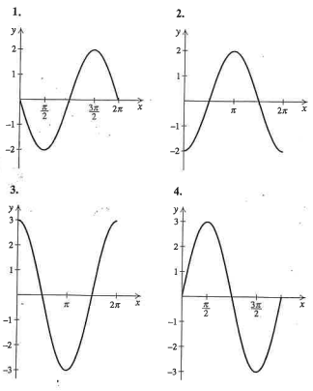
12. Determine the amplitude, period, and phase shift for each function:
a. $y=-2\cos{x}$ b. $y=-4\cos{x}$
c. $y=cos⁡(x-\frac{π}{2})$ d. $y=\sin{(x+\frac{π}{2})}$
e. $y=-2\sin\left(x+\frac{π}{3}\right)$ f. $y=-3\sin\left(x-\frac{π}{6}\right)$
13. Determine the amplitude and phase shift for each function. Also, sketch one period of the graph. Be sure to indicate five points (start, end, half, and quarter points).
a. $y=-\sin{x}$ b. $y=-\cos{x}$
c. $y=-3\sin{x}$ d. $y=4\sin{x}$
e. $y=\frac{1}{2}\cos{x}$ f. $y=\frac{1}{3}\cos{x}$
g. $y=\sin{(x+π)}$ h. $y=cos⁡(x-π)$
i. $y=\cos{(x-\frac{π}{3})}$ j. $y=\cos{(x-\frac{π}{4})}$
k. $y=\cos{x+2}$ l. $y=\cos{x-3}$
m. $y=-\sin{x-1}$ n. $y=-\sin{x+2}$
o. $y=\sin\left(x+\frac{π}{4}\right)+2$ p. $y=\sin\left(x-\frac{π}{2}\right)-2$
q. $y=2 cos\left(x+\frac{π}{6}\right)+1$ r. $y=3\sin\left(x+\frac{2π}{3}\right)-2$
s. $y=-2\sin\left(x-\frac{π}{3}\right)+1$ t. $y=-3\cos\left(x+\frac{π}{3}\right)-1$
14. Determine the amplitude, period, and phase shift for each function:
a. $y=3\sin{4x}$ b. $y=-\cos\left(\frac{x}{2}\right)+3$
c. $y=-2\cos{(2x+\frac{π}{2}})-1$ d. $y=4\cos\left(3x-2π\right)$
e. $y=-2\sin{(πx-π)}$ f. $y=\sin{(\frac{πx}{2}+π)}$
15. Write an equation for a sine curve that has the given amplitude, period, and phase shift:
a. $3, \frac{π}{4}$ , $\frac{π}{8}$ right b. $4, π$ , $π$right
c. 5, 2, 6 right d. 2, 3, 5

16. Find the equation for each curve based on the description:
a. The graph of $y=\sin{x}$ is reflected over the $x$-axis, shifted $\frac{π}{4}$ to the right, and translated one up.
b. The graph of $y=\cos{x}$ is reflected over the $x$-axis, shifted $\frac{π}{6}$ to the left, and translated two down.
c. The graph of $y=\cos{x}$ is vertically expanded by a factor of 3, reflected over the $x$-axis, shifted $π$ to the right, and translated two down.
d. The graph of $y=\sin{x}$ is vertically expanded by a factor of 4, reflected over the $x$-axis, shifted $\frac{π}{2}$ to the left, and translated one up.
17. Sketch at least one period of the graph of each function. Be sure to indicate five points (start, end, half, and quarter points).
a. $y=\sin{3x}$ b. $y=\cos{ \frac{x}{3}}$
c. $y=-\sin{2x}$ d. $y=-\cos{3x}$
e. $y=\cos{4x+2}$ f. $y=\sin{3x-1}$
g. $y=-\sin{\frac{x}{4}}+2$ h. $y=-\cos{\frac{x}{5}}+3$
i. $y=\sin{(\frac{π}{3}x)}$ j. $y=\sin{(\frac{π}{4}x)}$
k. $y=\sin{(2\left(x-\frac{π}{2}\right))}$ l. $y=\sin{(3\left(x+\frac{π}{3}\right))}$
m. $y=\sin{(\frac{π}{2}x+\frac{3π}{2})}$ n. $y=\cos{(\frac{π}{3}x-\frac{π}{3})}$
o. $y=2\cos\left(2\left(x+\frac{π}{6}\right)\right)+1$ p. $y=3\cos\left(4\left(x-\frac{π}{2}\right)\right)-1$
q. $y=-\frac{1}{2}\sin\left(3\left(x-\frac{π}{6}\right)\right)-1$ r. $y=-\frac{1}{2}\sin\left(4\left(x+\frac{π}{4}\right)\right)+1$
18. Write an equation of the form $y=a\sin{(b\left(x-c\right)+d}$ whose graph is provided:
(Note: $a>0, c>0$)
a.
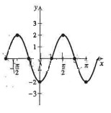
b.
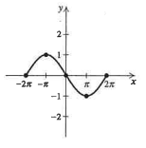
c.
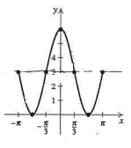
d.
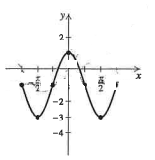
19. True or False:
a. $\sec\left(\frac{π}{4}\right)=\frac{1}{\sin\left(\frac{π}{4}\right)}$ b. $\cot\left(\frac{π}{2}\right)=\frac{1}{\tan\left(\frac{π}{2}\right)}$
c. $\csc{\frac{π}{3}=\frac{2\sqrt{3}}{3}}$ d. $\tan\left(\frac{5π}{2}\right)=0$
e. $\csc\left(\frac{2π}{3}\right)=\frac{2\sqrt{3}}{3}$
f. The graph of $y=\tan{3x}$ has vertical asymptotes at $x=±\frac{π}{6}$
20. Sketch at least one period of each of the following:
a. $y=\tan{3x}$ b. $y=\tan{4x}$
c. $y=\tan{πx}$ d. $y=\tan{\frac{πx}{2}}$
e. $y=-2\tan{x}$ f. $y=-\tan{(x-\frac{π}{2}})$
g. $y=\tan{(\frac{π}{2}x-\frac{π}{2})}$ h. $y=\tan{(\frac{π}{4}x+\frac{3π}{4})}$
21. A sound wave is a sinusoidal curve, as illustrated by the oscilloscope image below. Determine the function that best describes this graph.
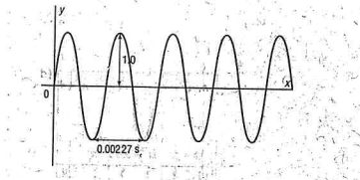
22. A vertical wheel with a radius of 50 cm rotates about an axle that is 60 cm above the ground. A marker is placed at the top of the wheel. The wheel completes one rotation every 4 seconds.
a. What is the amplitude, period, phase shift, and vertical displacement?
b. Write an equation of a cosine function that models the motion of the wheel.
23. The Fisheries and Oceans Canada website provided the following data for tide heights at Rankin Inlet on May 9, 2011.
Low tide: 1.0 m at 02:09, and 0.9 m at 14:28
High tide: 3.6 m at 08:09, and 3.7 m at 20:49
Assume the tide heights can be modeled using a sinusoidal function.
a. Write an equation of a sinusoidal function that models the data.
b. Use the function to estimate the tide height at 09:00. Round your answer to the nearest half-meter.

24. A water wheel has diameter 10 m and completes 4 revolutions each minute. The axle of the wheel is 8 m above a river.
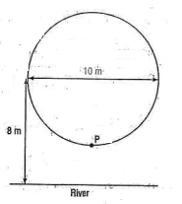
a. The wheel is at rest at time $t=0$ s, with point $P$ at the lowest point on the wheel. Determine a function that models the height of $P$above the river, $h$ meters, at any time $t$ seconds.
b. Find the height of $P$ after 35 seconds.
c. Find the times, to the nearest tenth of a second, in the first 15 seconds of motion that $P$ is 11 m above the river.

Answers
1. F 2. F 3. F 4. T 5. T 6. T 7. F 8. T 9. T 10. T
11. i 4 ii 3 iii 1 iv 2
12. a. Amplitude = 2; Period = $2π$; Phase Shift = 0
b. Amplitude = 4; Period = $2π$; Phase Shift = 0
c. Amplitude = 1; Period = $2π$; Phase Shift = $\frac{π}{2}$ right
d. Amplitude = 1; Period = $2π$; Phase Shift = $\frac{π}{2}$ left
e. Amplitude = 2; Period = $2π$; Phase Shift = $\frac{π}{3}$ left
f. Amplitude = 3; Period = $2π$; Phase Shift = $\frac{π}{6}$ right
13. a. Amplitude = 1; Phase Shift = 0
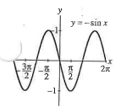
b. Amplitude = 1; Phase Shift = 0
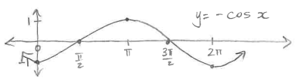
c. Amplitude = 3; Phase Shift = 0
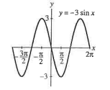

d. Amplitude = 4; Phase Shift = 0
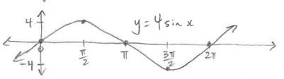
e. Amplitude = $\frac{1}{2}$; Phase Shift = 0
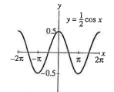
f. Amplitude = $\frac{1}{3}$; Phase Shift = 0
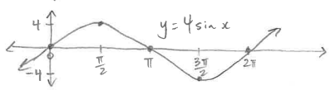
g. Amplitude = 1; Phase Shift = $π$ left
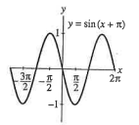
h. Amplitude = 1; Phase Shift = $π$ right
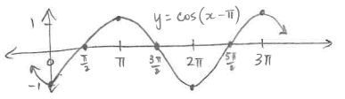
i. Amplitude = 1; Phase Shift = $\frac{π}{3}$ right
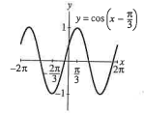
j. Amplitude = 1; Phase Shift = $\frac{π}{4}$ left
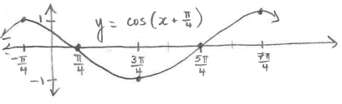
k. Amplitude = 1; Phase Shift = 0
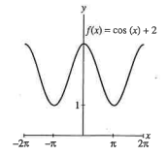
l. Amplitude = 1; Phase Shift = 0
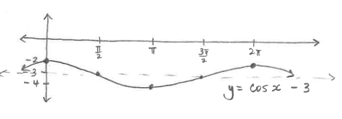

m. Amplitude = 1; Phase Shift = 0
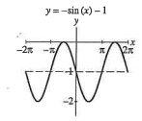
n. Amplitude = 1; Phase Shift = 0
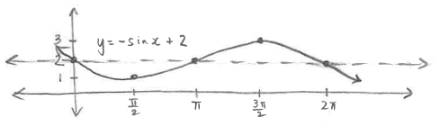
o. Amplitude = 1; Phase Shift = $\frac{π}{4}$ left
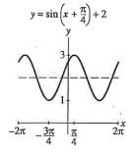
p. Amplitude = 1; Phase Shift = $\frac{π}{2}$ right
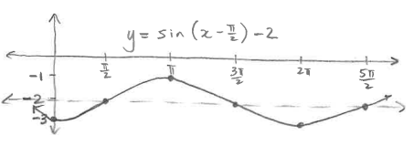

q. Amplitude = 2; Phase Shift = $\frac{π}{6}$ left
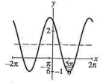
r. Amplitude = 3; Phase Shift = $\frac{2π}{3}$ left
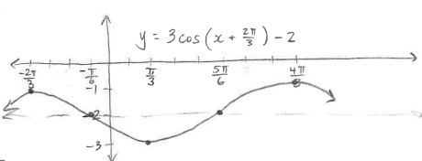
s. Amplitude = 2; Phase Shift = $\frac{π}{3}$ right
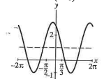
t. Amplitude = 3; Phase Shift = $\frac{π}{3}$ left
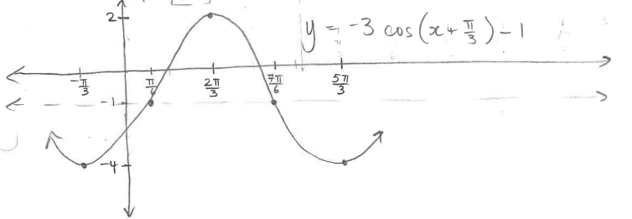
14. a. Amplitude = 3; Period = $\frac{π}{2}$ ; Phase Shift = 0
b. Amplitude = 1; Period = $4π$ ; Phase Shift = 0
c. Amplitude = 2; Period = $π$ ; Phase Shift = $\frac{π}{4}$ left
d. Amplitude = 4; Period = $\frac{2π}{3}$ ; Phase Shift = $\frac{2π}{3}$ right
e. Amplitude = 2; Period = 2 ; Phase Shift = 1 right
f. Amplitude = 1; Period = 4 ; Phase Shift = 2 left
15. a. $y=±\sin{(8\left(x-\frac{π}{8}\right))}$ b. $y=±4\sin{(2\left(x-π\right))}$
c. $y=±5\sin{(π\left(x-6\right))}$ d. $y=±2\sin{(\frac{2π}{3}\left(x-5\right))}$
16. a. $y=-\sin\left(x-\frac{π}{4}\right)+1$ b. $y=-\cos\left(x+\frac{π}{6}\right)-2$
c. $y=-3\cos\left(x-π\right)-2$ d. $y=-4\sin\left(x+\frac{π}{2}\right)-1$
17. a.
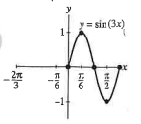
b.
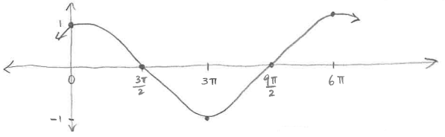

c.
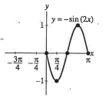
d.
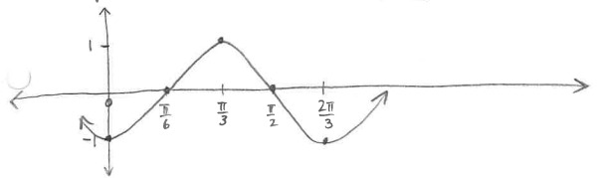
e.
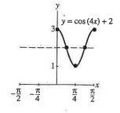
f.
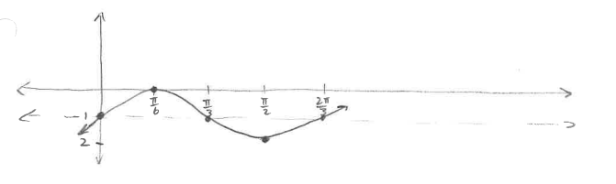

g.
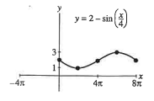
h.
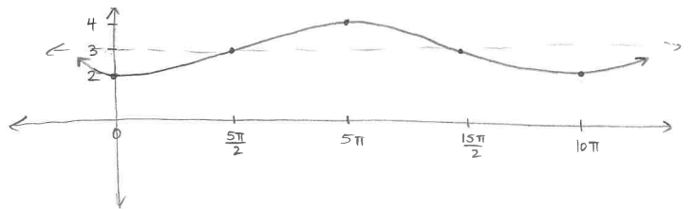
i.
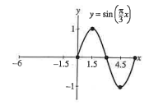
j.
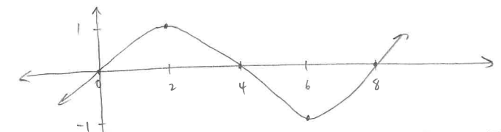

k.
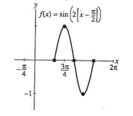
l.
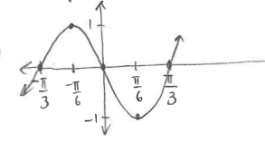
m.
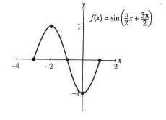
n.
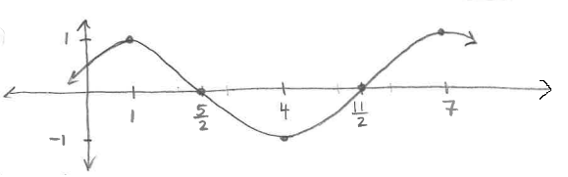
o.
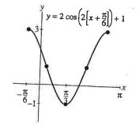
p.
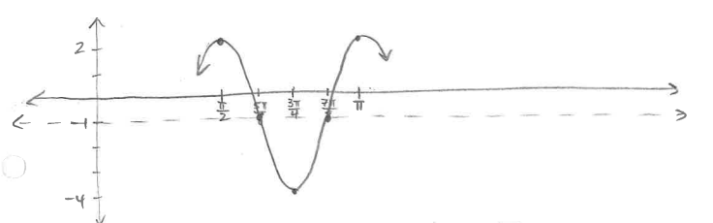
q.
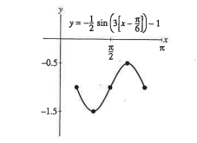

r.
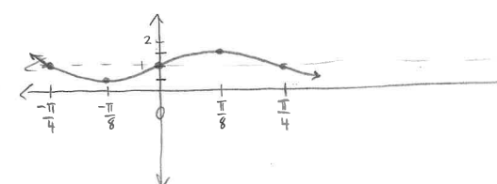
18. a. $y=2\sin\left(2\left(x-\frac{π}{4}\right)\right)$ b. $y=\sin\left(\frac{1}{2}\left(x-2π\right)\right)$
c. $y=3\sin\left(\frac{3}{2}\left(x-π\right)\right)+3$ d. $y=2\sin\left(2\left(x-\frac{3π}{4}\right)\right)-1$
19. a. T b. T c. T d. F e. T f. T
20. a.
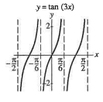
b.
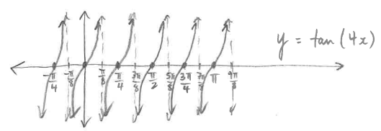

c.
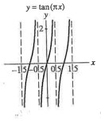
d.
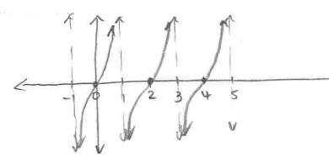
e.
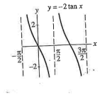
f.
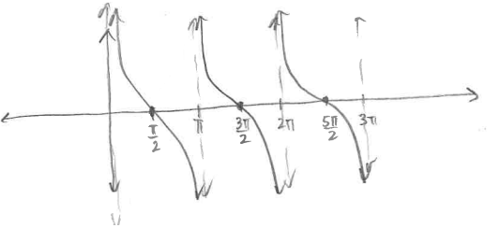
g.
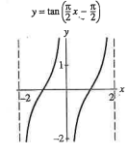
h.
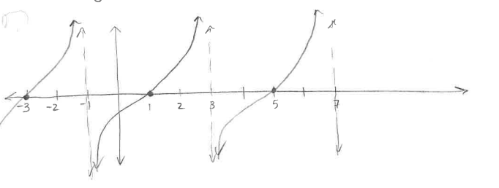
21. $y=\sin{\frac{2πx}{0.00227}}$
22. a. Period = 4; Phase Shift = 0; Amplitude = 50; Vert. Displacement = 60 up
b. $h=50\cos{\frac{π}{2}t}+60$
23. a. Assume minimum at 0.95 m; assume maximum at 3.65 m.
$y=-1.35\cos\left(\frac{π}{6}\left(x-2\right)\right)+2.3$ or $y=1.35\cos\left(\frac{π}{6}\left(x-8\right)\right)+2.3$
$y=-1.35\sin\left(\frac{π}{6}\left(x-11\right)\right)+2.3$ or $y=1.35\sin\left(\frac{π}{6}\left(x-5\right)\right)+2.3$
b. Approximately 3.5 m
24. a. $y=-5\cos{\frac{2π}{15}x+8}$
b. 10.5 m
c. Approximately 5.3 s and 9.7 s

