Trigonometry Part 2 – Trig. Identities
PRACTICE TEST REVIEW
Multiple Choice Section:
1. Simplify: $\frac{2\tan{x}}{\cos^{2}x + \sin^{2}x -\tan^{2}x}$
a. $2\sin{x}$ b. $\sin{2x}$ c. $\tan{2x}$ d. $2\cot{x}$

2. Solve: $2\cos^{2}x-5\cos{x+2=0; 0≤x<2π}$
a. 0 b. $\frac{π}{3}$ , $\frac{5π}{3}$ c. $\frac{2π}{3} , \frac{4π}{3}$ d. $\frac{π}{3} , \frac{2π}{3} , \frac{4π}{3} , \frac{5π}{3}$

3. Simplify: $\cos{(\frac{3π}{2}+x)}$
a. $\sin{x}$ b. $-\sin{x}$ c. $\cos{x}$ d. $-\cos{x}$

4. Which of the following is equivalent to $\sin{x\cos{x}}$ ?
a. $\frac{1}{2}\sin{2x}$ b. $2\sin{2x}$ c. $2\sin{x}$ d. $\frac{1}{2}\sin{x}$

5. Simplify: $\frac{\sec{x}}{\tan{x+\cot{x}}}$
a. $\cos{x}$ b. $\sin{x}$ c. $\sec{x}$ d. $\csc{x}$

6. Simplify: $\frac{\sqrt{\sec^{2}x-1}}{\sqrt{\csc^{2}x-1}}$
a. $\tan^{2}x$ b. $\cot^{2}x$ c. $\tan^{4}x$ d. $\cot^{4}x$

7. Which of the following is equivalent to $\frac{2\tan{x\cot{2x}}}{1+\tan{x}}$ ?
a. $1-\tan{x}$ b. $\frac{1}{1-\tan{x}}$ c. $\frac{1}{1+\tan{x}}$ d. $\cot{x}$

8. Simplify: $\frac{2\tan{x}}{\cos^{2}x + \sin^{2}x + \tan^{2}x}$
a. $\sin{x}$ b. $2\sin{x}$ c. $\sin{2x}$ d. $2\sin{2x}$
9. Which of the following is equivalent to ${(\sin^{2}x-\cos^{2}x)}^{2}-\sin^{2}2x$ ?
a. $-2\sin^{2}2x$ b. $2\sin^{2}2x$ c. $-\cos{4x}$ d. $\cos{4x}$

10. Which of the following is equivalent to $4\sin{6x\cos{6x}}$ ?
a. $\sin{6x}$ b. $\sin{12x}$ c. $2\sin{3x}$ d. $2\sin{12x}$

11. Which of the following is equivalent to $\frac{\cos{2x-1}}{\sin{2x}}$ ?
a. $\cot{x}$ b. $\tan{x}$ c. $-\cot{x}$ d. $-\tan{x}$

12. Determine an expression for $x$ such that $\frac{2-\cos^{2}x}{\sin{x}}=x+\sin{x}$ is an identity.
a. $\csc{x}$ b. $\sec{x}$ c. $\cos{x}$ d. $\cos^{2}x$

13. How many solutions does $\cos{2x\cos{x-\sin{2x\sin{x=0}}}}$ have over the interval $0≤x<2π$ ?
a. 2 b. 3 c. 4 d. 6

14. Solve for , where $0≤x<2π$: $2\sec^{2}x+5\sec{x-3=0}$. Answer to the nearest hundredth.
a. 1.23, 5.05 b. 1.91, 4.37 c. 3.48, 5.94 d. 1.05, 1.91, 4.37, 5.23

15. If $\sin{x=a}$ and $0<x<\frac{π}{2}$ , determine an expression for $\cos{(π+x)}$.
a. $1-a$ b. $a-1$ c. $\sqrt{1-a^{2}}$ d. $-\sqrt{1-a^{2}}$

16. Simplify: $2\cot{x \sin^{2}x}$
a. $\frac{\sin{2x}}{2}$ b. $\sin{2x}$ c. $\frac{2\sin^{3}x}{\cos{x}}$ d. $\cos{2x\sin{x}}$

17. Simplify: $\cot^{2}x \sin^{2}x+\cos^{2}x$
a. $\cos^{4}x$ b. $2\cos^{2}x$ c. $\sin^{4}x$ d. $\cot^{2}x$

Written Section:
1. Prove the following identity: $(1+\csc{x)(1-\sin{x)=\cot{x\cos{x}}}}$

2. Prove the following identity: $\frac{\sec{x-\cos{x}}}{\tan{x}}=\sin{x}$

3. Solve for $x$, where $0≤x<2π$: $2\tan^{2}x-5\tan{x-3=0}$. If exact answers are possible, provide a diagram(s). If exact answers are not possible, round your answers to the nearest hundredth.

4. Prove the following identity: $\frac{\sin{2x}}{2-2\cos^{2}x}=\cot{x}$

5. Solve for $x$, where $0≤x<2π$: $\sec^{2}x-\sec{x-6=0}$. If exact answers are possible, provide a diagram(s). If exact answers are not possible, round your answers to the nearest hundredth.

6. Solve for $x$, where $0≤x<2π$: $3\sin^{2}x-8\sin{x+4=0}$. If exact answers are possible, provide a diagram(s). If exact answers are not possible, round your answers to the nearest hundredth.

Answers:
Multiple Choice:
1. c 2. b 3. a 4. a 5. b 6. a 7. a 8. c 9. d 10. d 11. d 12. a 13. d
14. b 15. d 16. b 17. b

Written:
1.
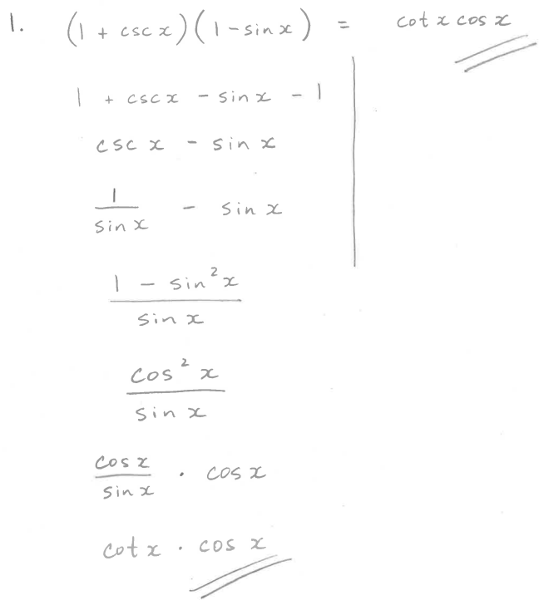
2.
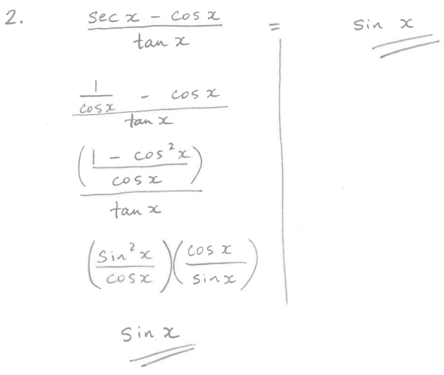

3.
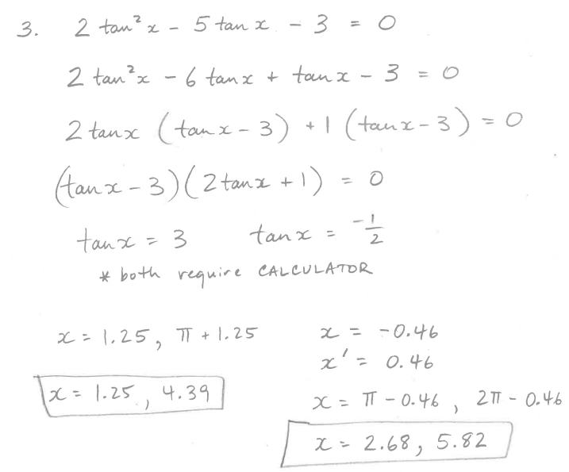
4.
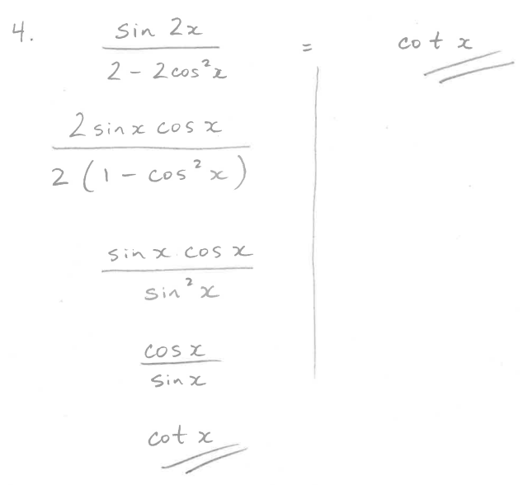
5.
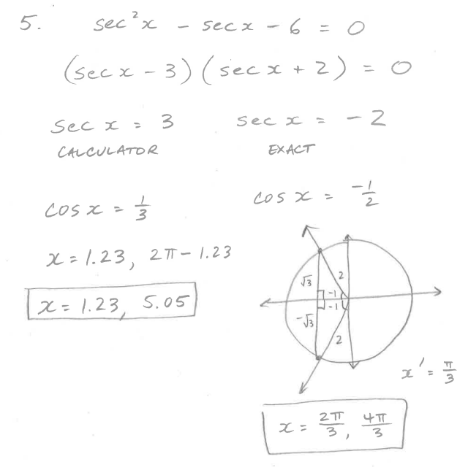
6.
