The Liver

- the liver is the largest internal organ in the body.

- it is often referred to as known as the blood’s ‘gatekeeper’.

- it lies predominantly in the upper right section of the abdominal cavity, just under the diaphragm.

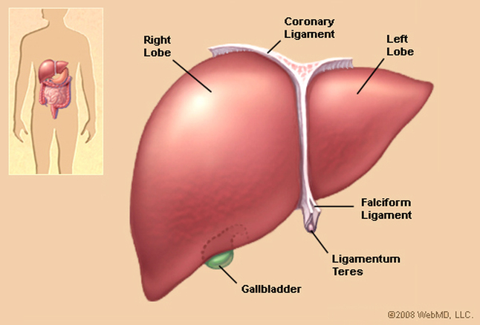

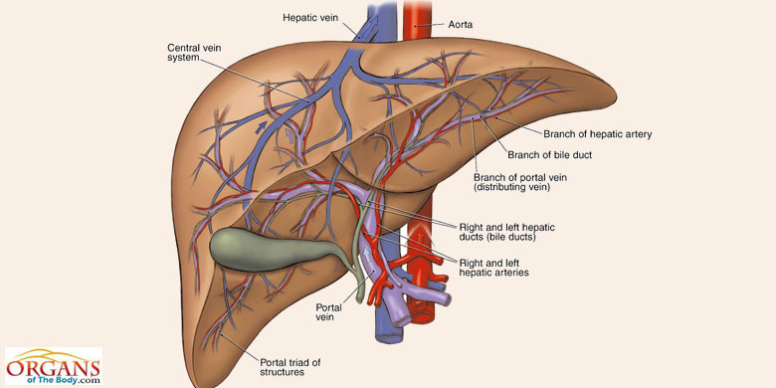
- it consists of two main lobes that are further subdivided into thousands of lobules, which are made up of cells (hepatocytes) that perform the various functions of the liver (see fig. 12.10 p. 222; fig. 12.11 p. 223).

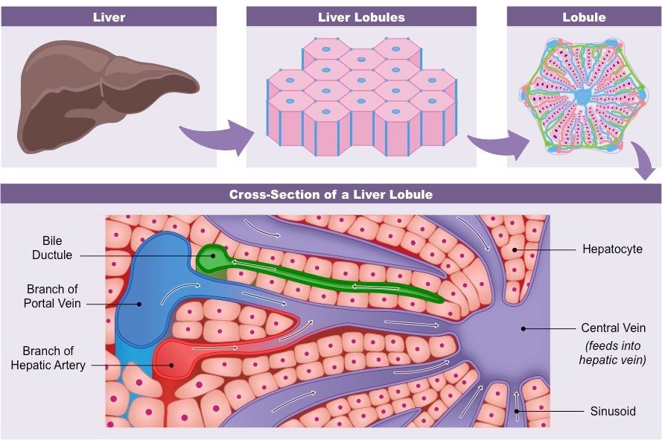

- lobules are separated by three primary branching structures:

i. a hepatic artery branch that provides oxygenated blood;

ii. a hepatic portal vein branch that provides nutrient-rich blood (from small intestine);

**all of these vessel branches eventually drain into the hepatic vein.

iii. a bile duct that transports bile to the gall bladder.

Liver Functions

1. Produces Bile – Recycles/Destroys Old Red Blood Cells

- Red blood cells (RBCs) live, on average, for 120 days.

- bile is made up of two general constituents:

1. Bile pigment bilirubin, which is derived from the breakdown of hemoglobin in old, retired RBCs – bilirubin is responsible for the yellow-green colour of bile. Bilirubin serves no useful purpose in the body; it exits the body as part of feces.

2. Bile salts derived from cholesterol – serve to emulsify fats in duodenum portion of SI.

- after it is produced, bile is sent to the gall bladder for storage.

- liver ‘malfunction’ (perhaps due to hepatitis or cirrhosis) can lead to an excess of bilirubin in the blood. Excess bilirubin causes jaundice, which presents with a yellowing of the skin. Jaundice can be more prevalent in newborns as they possess roughly 40% more RBCs per unit mass than adults, meaning that there is more RBC recycling per gram of body weight and thus, more bilirubin production. This, combined with the fact that the liver is just beginning to ‘work’ in its new ‘career’, may lead to jaundice. Extremely high bilirubin counts might lead to brain cell malfunction in some newborns (this is rare).

2. Mineral and Vitamin Storage

- during its breakdown of RBCs, the liver removes Fe²⁺ ions from hemoglobin and sends them to the bone marrow in order to be used in the production of new RBCs (Fe²⁺ is recycled). This process is not 100% efficient, thus, Fe²⁺ is required in our diet.

- the liver cells absorb fat-soluble vitamins A, D, E, and K from the blood and store them for future use.

3. Regulates Blood-Glucose Level

- glucose should comprise approximately 0.1% of plasma.

- if the level of glucose in the blood is too high (usually, just after eating), the hormone insulin will be released by the pancreas causing glucose to be taken out of the blood and stored in the liver (and muscle cells and adipose cells) as glycogen.

- if the level of glucose in the blood is too low (usually, between eating periods), the hormone glucagon will be released by the pancreas causing glycogen breakdown to glucose in the liver (and muscle cells (but not necessarily adipose cells!)) and subsequent release of that glucose into the bloodstream.

4. Deaminates Amino Acids – Produces Urea

- if necessary (due to a low carbohydrate diet, or low glycogen in storage), the liver converts amino acids (of various blood proteins) into glucose in order to maintain blood-glucose level.

- this process removes amino groups (-NH₂) from amino acids, producing toxic ammonia, which the liver then converts to urea (our primary nitrogen-based waste product).
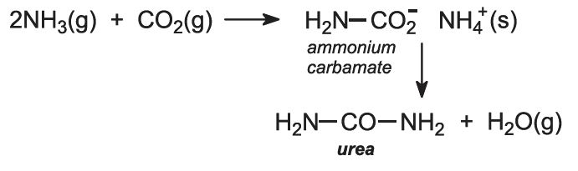
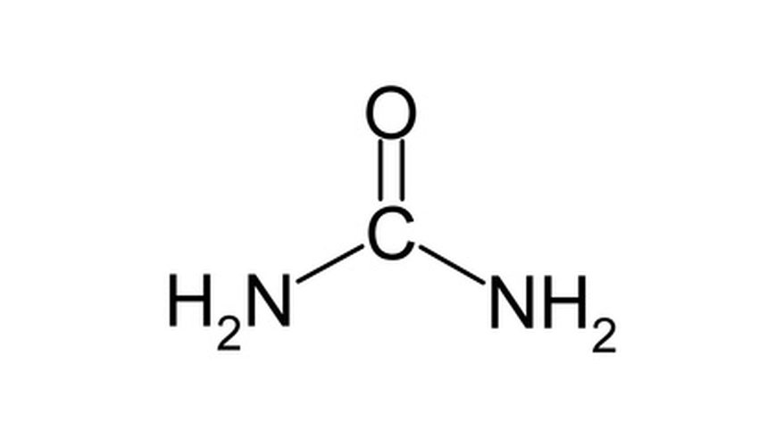Urea

- urea is released into the blood of the hepatic vein where it eventually is removed from the blood by the kidneys during the production of urine.

5. Detoxifies Blood

- the liver filters out and destroys toxins from the blood (eg. drugs, alcohol)

- this detoxification damages the liver over time.
- eg.: the liver metabolizes alcohol into fatty acids, which can lead to scarring in the liver tissue and cause cirrhosis (p. 223).

6. Produces Various Blood Proteins from Amino Acids

- examples include:

- fibrinogen - important in blood clotting;

- prothrombin – important in blood clotting;

- albumin - helps to maintain osmotic pressure of the blood.

7. Manipulation of Fats

- the liver produces fats from excess fatty acids and glycerol.

- the liver also has the ability to convert two glycerol molecules to glucose when blood-glucose levels are low (similar to deamination of amino acids).

Insulin and Glucagon

- both are hormones secreted from specialized cells in the pancreas called Islets of Langerhans.

- insulin is released from the pancreas directly into the blood when there is a HIGHER than usual blood-glucose level conditions that are normally evident immediately after eating.

- insulin acts to DECREASE blood-glucose level by stimulating the uptake of glucose by certain cells:
A. Liver cells store glucose as glycogen;

B. Muscle cells can use glucose in either of the following ways:

i). Metabolize (through cellular respiration) glucose and
use the energy to build muscle proteins

ii). Store glucose as glycogen;

C. Adipose (Fat) tissue cells convert glucose to glycerol for the production of neutral fats.

- glucagon is an opposing hormone, also released by the pancreas, that produces the opposite effects in the body leading to an increase in blood-glucose level (generally, in between meals).

- Diabetes mellitus is a type of diabetes in which the pancreas has difficulty producing insulin (type I), or the liver and muscle cells have difficulty responding to insulin’s arrival (type II) – see p. 409.

- either way, cells have a hard time removing glucose from the blood which eventually leads to a lack of ATP production. In fact, diabetes is sometimes referred to as “Starvation in the midst of plenty.”

